**History of Kenilworth Croquet Club**

Kenilworth Croquet Club came late to the historic town of Kenilworth but its activities are now firmly in the area’s sporting calendar. Progress made since the Club was formed in 1989 bears witness to the enthusiasm and ambition of a small team of pioneers.

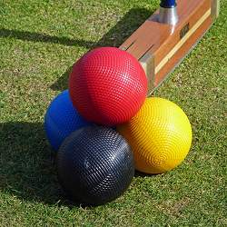

In 1989 the original founders - Doug Taylor, then the President of Kenilworth Lawn Tennis & Squash Club, and nine other members of the Club were presented with a unique opportunity. The Tennis Club, having extensively invested in resurfacing its playing areas, had left two grass courts redundant. It was on these foundations that the first lawn was created and croquet commenced in 1989 with a series of coaching sessions by Chris Hudson of the Croquet Association.

It was inevitable that if the Club was to attract more members and to be able to enter tournaments a second lawn was needed. This started from scratch in April 1995 with members led by Peter Dennis toiling with machines and physical "blood, sweat and tears" to remove an encroaching embankment, clearing the ground and spreading 100 tons of top soil. After much raking and levelling, grass seed was sown just twelve months later and the lawn was opened for play in August 1996.

Peter Dennis (who has now retired) successfully introduced a continuous planned maintenance and improvement programme which has resulted in the lawns being recognised as being of a high standard and equal to the best in the Greater Midlands area.

Ray Clipson took over as lawn manager in 2008 and has aims to continue improving the playing surface of the lawns

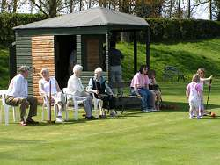

The Club is in the West Midlands Federation Leagues and members compete for a range of trophies.

The Croquet Club benefits from the extensive facilities of the Kenilworth Lawn Tennis & Squash Club. It was recognised that, to cater for a growing number of members and events, a pavilion adjacent to the lawns was essential. Members embarked upon a programme to design, make and construct a pavilion and this was completed in 2000.

The Club is determined to maintain this continuous development into the future.

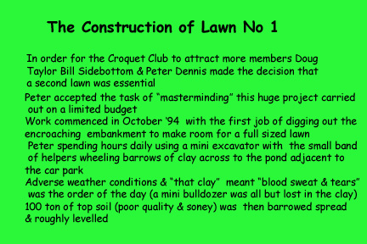

**2. Removing the clay from the whole lawn area.**

**Doug Taylor/Roger Tribe/John Kelly/Bill Sidebottom and an Aussi mate.**

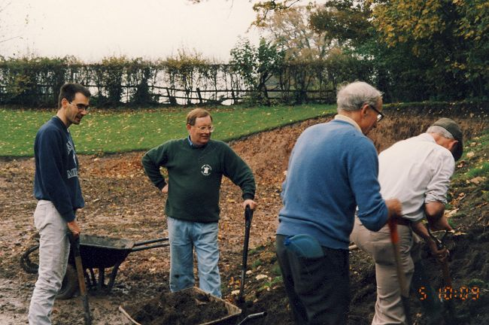

**3. The bank has been dug out and still more clay. October 1995**

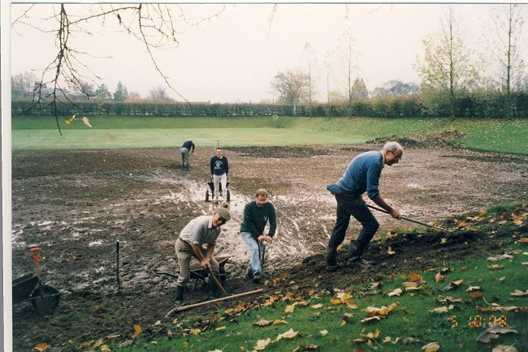

**4. Doug and the Aussie, still smiling.**

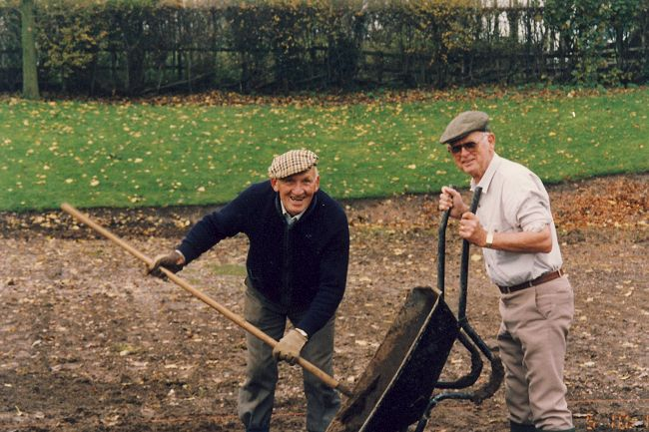

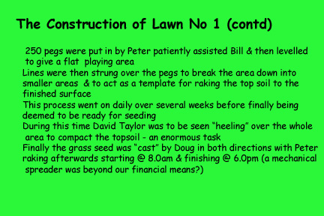

**6. Denis (former groundsman) and Peter loading and barrowing top soil.**

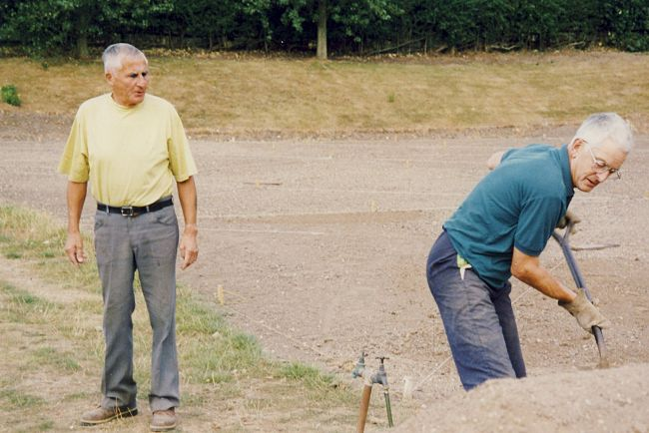

**7. The level pegs and lines required to achieve a "true" playing surface.**

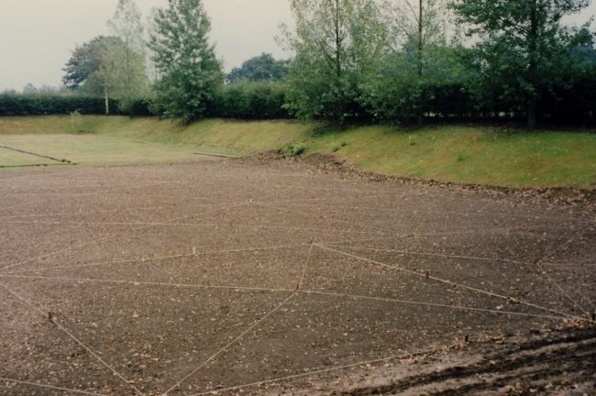

**8. The lonely worker raking and levelling "forever" - a tedious job.**

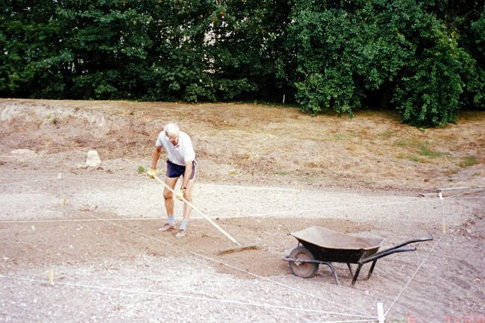

**9. Peter - a dedicated raker extraordinaire**

**.**

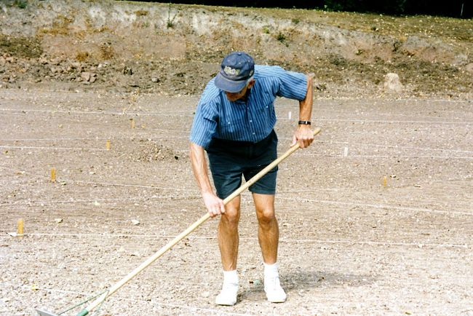

**10. James Ward using the back of the rake to "fine tune" the levelling.**

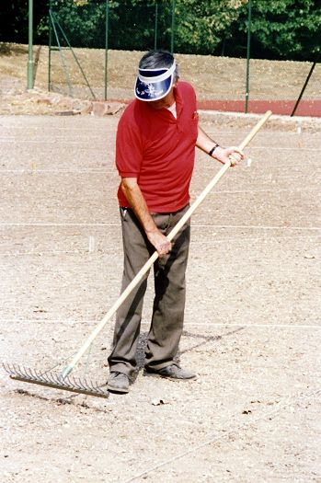

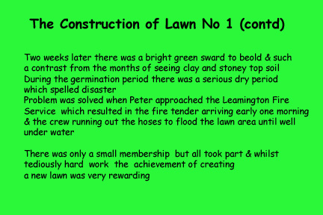

**12. Doug Taylor giving the lawn the 1st cut in October 1995 - brilliant .. (note lawn No 2 scarified and top dressed at the end of the season).**

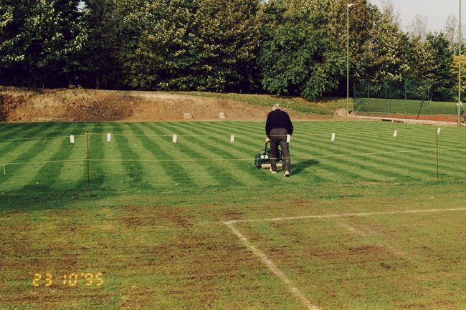

**13. Doug and Peter ..grass miraculously appeared! Job done! Oct 1995**

